I - Fill in the sentences with the correct form (past simple) of the appropriate verb, and then match the sentences to the pictures.



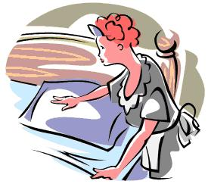


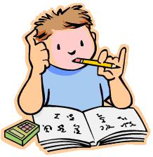
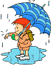


1) Mum _washed up_ after lunch.
2) The maid ___________________ the beds in the rooms.
3) It ___________________ a lot yesterday.
4) The boys ___________________ after school.
5) The fortune teller ___________________ me my future.
6) Dave ___________________ a slice of pizza.
7) The couple ___________________ TV last night.
8) Tim ___________________ the table.
9) Dad ___________________ a fairy tale to his children.
10) Dave ___________________ a bath.
11) The ambulance ________________ the injured man to the hospital.
12) Owen ___________________ the homework.
13) Fred ___________________ a cold yesterday.
14) Jane ___________________ in the disco last weekend.
15) The couple ___________________ on the bench in the park.

1
A) READ
M) RAIN
N) DO
O) DANCE
K) HAVE
C) SET
I) MAKE
H) SIT
D) FIGHT
F) TELL
G) TAKE
B) CATCH
J) WATCH
E) WASH UP
L) EAT

II - Fill in the sentences with the correct form (past simple) of the appropriate verb, and then match the sentences to the pictures.
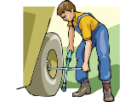
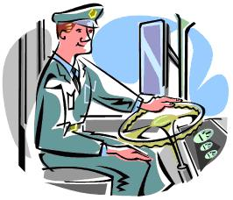



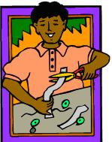
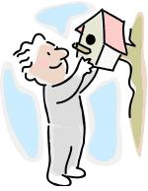
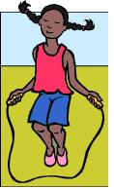
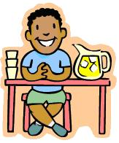
1) Daisy _skipped_ the rope in the garden?
2) Anne ___________________ on her homework.
3) The young lady ___________________ on the beach.
4) Mary ___________________ the litter into the recycling bin.
5) Tom ___________________ lemonade.
6) Joe ___________________ the paper into smaller pieces.
7) The family ___________________ on holiday on Monday.
8) The bus driver ___________________ the bus to the station.
9) Robert ___________________ a birdhouse on the tree.
10) Paul and James ___________________ presents to each other.
11) The lorry driver ___________________ the wheel of the lorry.
12) Jasmine ___________________ the piano.
13) Hanna ___________________ for the test at home.
14) Leila ___________________ in the sea.
15) Kyle ___________________ home.

1
A) SLEEP
M) RUN
N) GIVE
O) CHANGE
C) SWIM
I) SKIP
H) LIE
D) DRIVE
F) DROP
G) CUT
B) SELL
J) STUDY
E) PLAY
L) GO
K) PUT

